**VISVESVARAYA TECHNOLOGICAL UNIVERSITY**

**“JnanaSangama”, Belgaum -590014, Karnataka.**



**LAB REPORT**

**on**

**BIG DATA ANALYTICS**

**(20CS6PEBDA)**

***Submitted by***

**N.AKHILESH KUMAR DUTT (1BM19CS092)**

***in partial fulfillment for the award of the degree of***

**BACHELOR OF ENGINEERING**

***in***

**COMPUTER SCIENCE AND ENGINEERING**



**B.M.S. COLLEGE OF ENGINEERING**

**(Autonomous Institution under VTU)**

**BENGALURU-560019**

**May-2022 to July-2022**

**B. M. S. College of Engineering,**

**Bull Temple Road, Bangalore 560019**

(Affiliated To Visvesvaraya Technological University, Belgaum)

**Department of Computer Science and Engineering**



**CERTIFICATE**

This is to certify that the Lab work entitled “**BIG DATA ANALYTICS**” carried out by **N.AKHILESH KUMAR DUTT(1BM19CS092),** who is bonafide student of **B. M. S. College of Engineering.** It is in partial fulfillment for the award of **Bachelor of Engineering in Computer Science and Engineering** of the Visvesvaraya Technological University, Belgaum during the year 2022. The Lab report has been approved as it satisfies the academic requirements in respect of a BIG DATA ANALYTICS **- (20CS6PEBDA)** work prescribed for the said degree.

Dr.Pallavi G B               **Dr. Jyothi S Nayak**

Assistant Professor Professor and Head

Department of CSE Department of CSE

BMSCE, Bengaluru BMSCE, Bengaluru

`

**Index Sheet**

|  |  |  |
| --- | --- | --- |
| **Sl. No.** | **Experiment Title** | **Page No.** |
| **1** | **MongoDB CRUD Demonstration** | **4** |
| **2** | **Cassandra Employee Database** | **6** |
| **3** | **Cassandra Library Database** | **8** |
|  |  |  |
|  |  |  |
|  |  |  |
|  |  |  |
|  |  |  |
|  |  |  |
|  |  |  |
|  |  |  |
|  |  |  |
|  |  |  |
|  |  |  |
|  |  |  |

**Course Outcome**

|  |  |
| --- | --- |
| CO1 | Apply the concept of NoSQL, Hadoop or Spark for a given task |
| CO2 | Analyze the Big Data and obtain insight using data analytics mechanisms. |
| CO3 | Design and implement Big data applications by applying NoSQL, Hadoop or Spark |

1. **MongoDB- CRUD Demonstration**

**CRUD (CREATE, READ, UPDATE, DELETE) OPERATIONS**

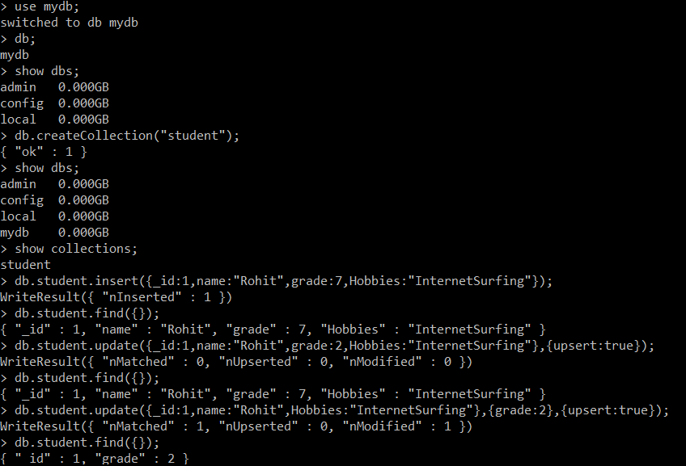

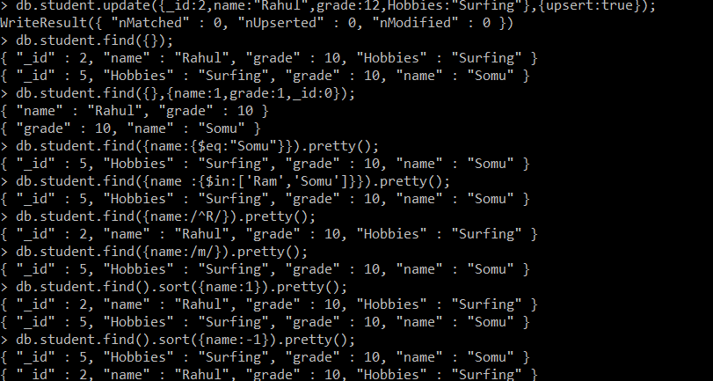

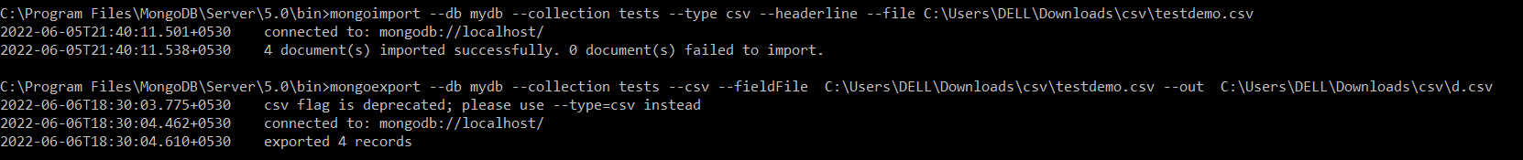

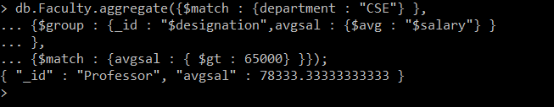

**2.Perform the following DB operations using Cassandra.**

1.Create a key space by name Employee

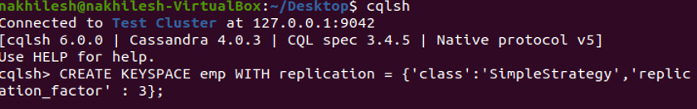

2.Create a column family by name Employee-Info with attributes Emp_Id Primary Key, Emp_Name, Designation, Date_of_Joining, Salary, Dept_Name

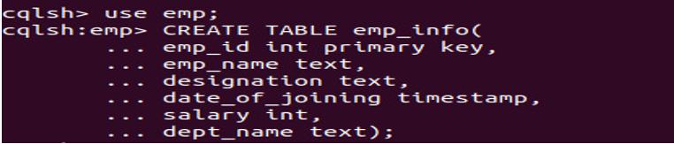

3.Insert the values into the table in batch

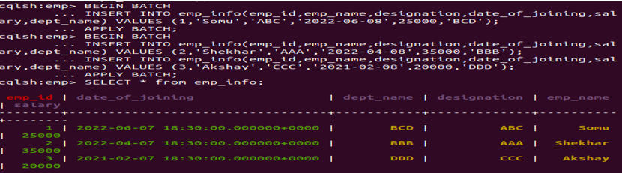

4. Update Employee name and Department of Emp-Id 2

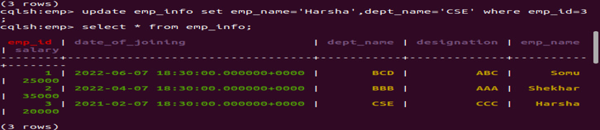

5. Sort the details of Employee records based on salary

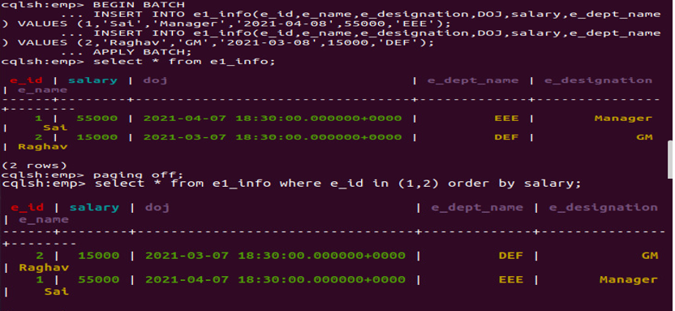

6. Alter the schema of the table Employee_Info to add a column Projects which stores a set of Projects done by the corresponding Employee



7. Update the altered table to add project names

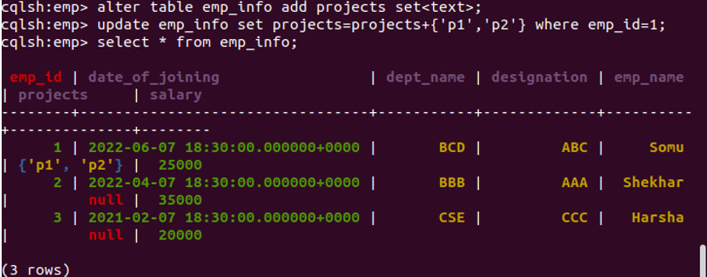

**3. Perform the following DB operations using Cassandra.**

1. Create a key space by name Library

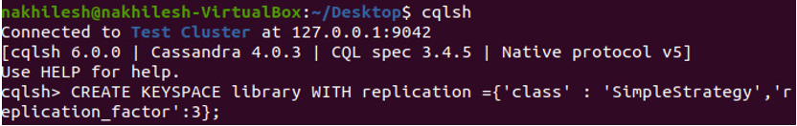

2. Create a column family by name Library-Info with attributes Stud_Id Primary Key,

Counter_value of type Counter,

Stud_Name, Book-Name, Book-Id, Date_of_issue

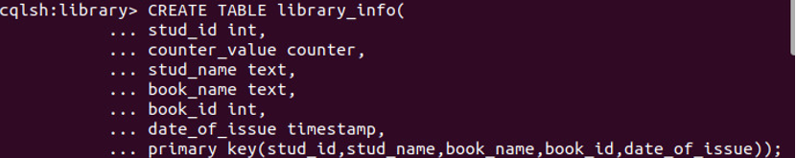

3. Insert the values into the table in batch

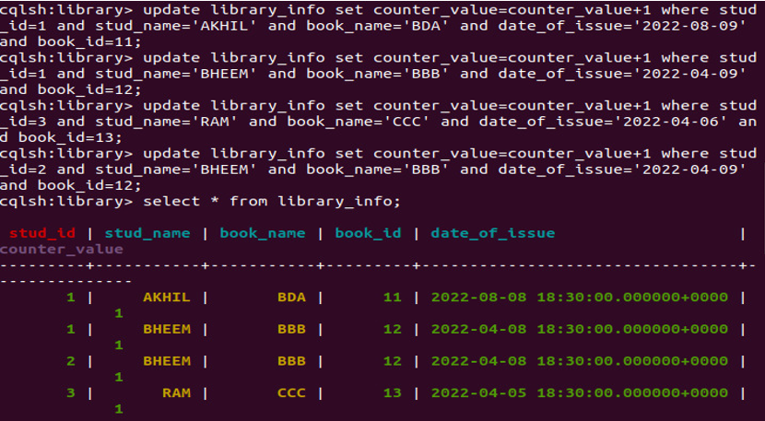

4.Display the details of the table created and increase the value of the counter

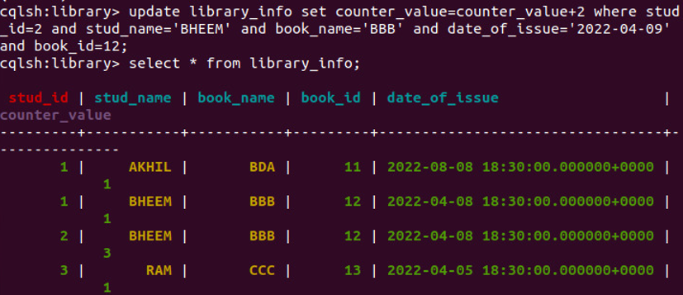

5. Write a query to show that a student with id 112 has taken a book “BDA” 2 times.

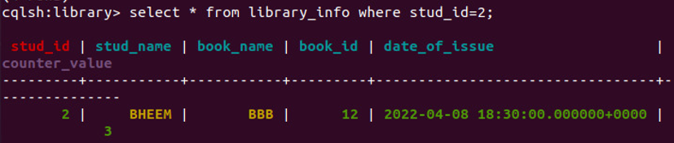

6. Export the created column to a csv file

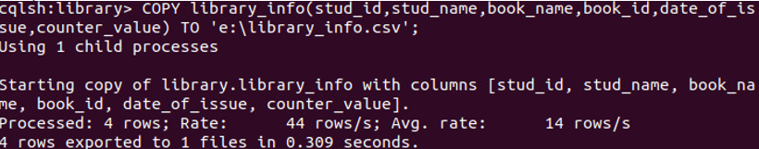

7. Import a given csv dataset from local file system into Cassandra column family

